Software Requirements

1. **Product Overview and Summary**

To have a small company become the next big thing like Facebook or WeChat, it is certainly a dream every programmer, marketing team, or your friend that puts all his money into that company’s stock and become rich could wish for. Even in the earlier days of AIM, Skype and Facebook, these ideas were grand successes, but now with the evolution of technology and everyone using the internet, they were the steppingstones for something much bigger. Kids, teens, and adults are fascinated by social media and instant messaging because it is so easy yet exciting to use because of the various features these software programs can let you do. If you were to check the market for these kinds of software applications, you’ll find companies like WhatsApp and WeChat, who have 3 million plus users daily, are making billions of dollars in revenue a year off their app. Due to the popularity and demand for this kind of product, our group decided to make our own social/web chat program that we believe users will want to use and become the next big thing.

Our product is a place where people become friends or find their friends so they can communicate with one another and a social gathering where you can see what your friends’ statuses, which can lead to conversation amongst each other, see what their thinking about or opinions on certain issues or drop a funny joke to make your friends laugh. Our web application aims to be for everyone and not just a selective group; we want everyone to meet new people, have social interaction with one another that could be somewhat difficult with our busy lives, and bring a user something fresh and new compared to the other social/chat applications like WeChat or WhatsApp. To give the user this new experience, we came up with the main functions that will make it happen. We have everything from being able to add a user, lookup an existing user, delete a user from your contact list, send messages to your friends, view chat history, accept/deny friend requests, block certain users, customize/set your profile, post statuses and view your friend statuses.

1. **Information Description**
   1. **UI**

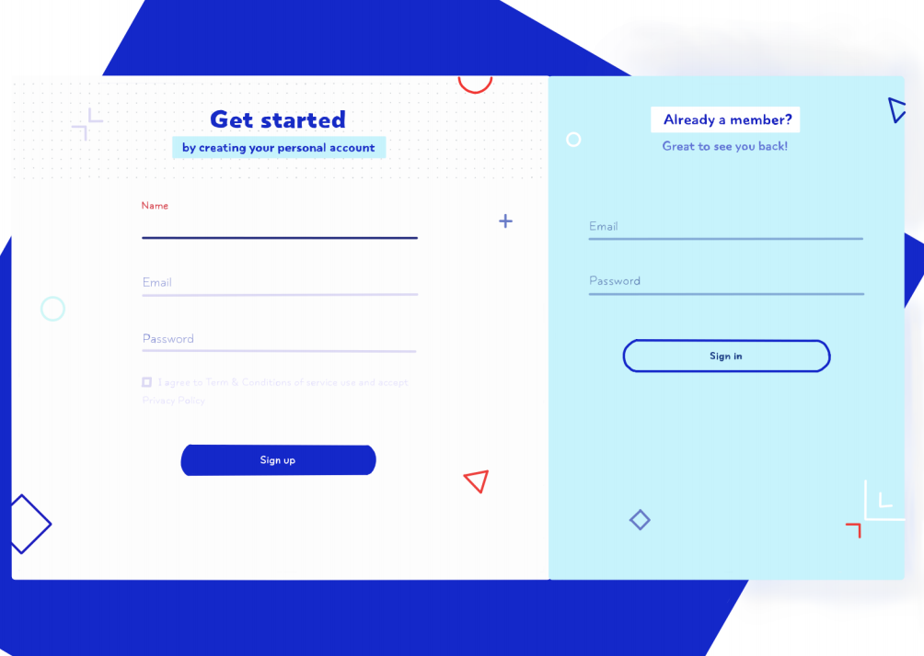

The left side is for user to register, the user can type in the username, email and password, by clicking to agree the agreement and the sign-up button the user can register their own account. If the user already has the account, they can go to the right side, directly type in their email address and password, and click the sign in button, the application will redirect the user to the main page.

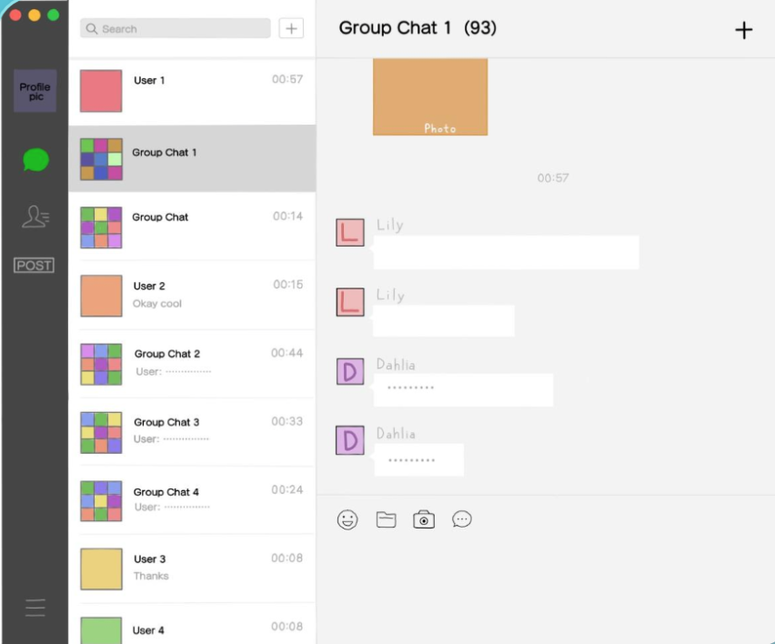

The main chatting page, the left side bar the message button will let the user to see all of their current chatting, the contact button will allow the user to see their full contact list, and the post button allow users to post feed. The left bottom button will allow the user to go to profile and setting. The middle part is for the user to see their current chatting, they can click each bar to chat with different people, or group. The right part is the chatting window, this is where the user can send text message, file and pictures. By clicking the right upper corner add button, users are able to create the group chat.

* 1. 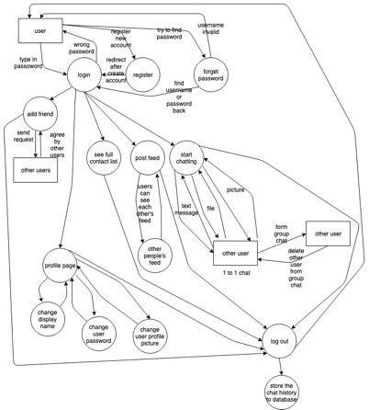**High Level Data Flow Diagram**

For the above DFD wish list components: Group chat features, sending files, and forgot password.

* 1. **Data Structure Representation & 2.4 Data Elements**

In the Database:

STRUCTURE : ELEMENTS

User: user_id, f_name, l_name, email, contactor_user, profile pic, admin

Post: user_id,post_feed,data_post

Message: user_id *2, message_detail

WISHLIST: Group: user_id *members_in_ chat, groupmessage_detail, members_in_chat

1. **Function Description & Limitations & IC cards**
2. Create Account:

Users will be able to create their own personal account/profile. They will choose a username upon creation which is unchangeable. For our wishlist we want to connect their account to an email.

This feature will not allow duplication of account usernames. Upon creation a user will only be able to set their username, password, and their profile name. Anything else will be managed by the profile manager.

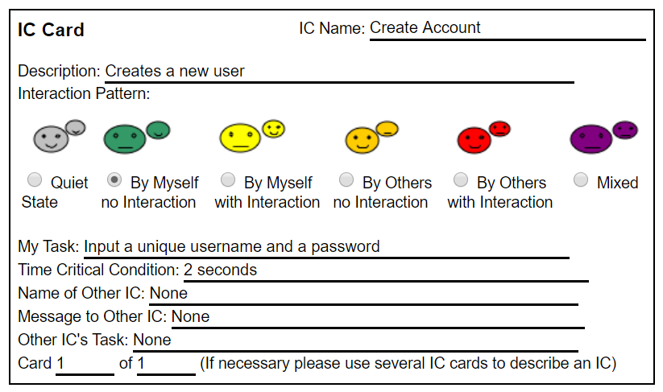

1. Add User:

Users will be able to add users by username and add them to their contact list, if a user is already a part of the contact list, this function will tell the user that the attempted add failed because their contact list already contains who they are trying to add. Upon success, a user will be added to the contact list.

This is not a search feature, so it is either the exact username or failure to add the user. A user may not add multiple users in one line either, each user must be added separately.

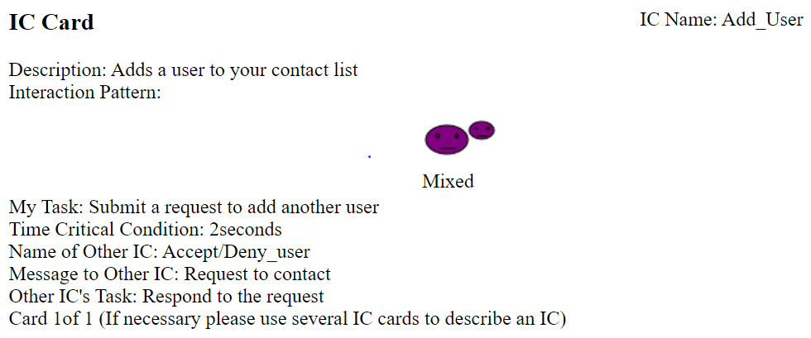

1. Lookup User:

This will allow users to look up usernames for closest matches from the database. This feature will have to match the usernames by searching the database for the input, users will be organized in a first match basis. The lookup feature will only work from the start of the username. For example, if there exists a user "ABCDEFGH" and a user "BCDEFGH", and a user looks up "BCDEF", the only result will be the second user "BCDEFGH".

This function does not allow to add, delete, or block users; to do those actions, a user must use those specific features. This feature will not sort users! It will not provide CLOSEST match, but FIRST match that contains and starts with the searched username; for example if in the database we have user ADS22 and user ADS in that order and a user searches "ADS", "ADS22" will be the first result, also if a user were to search "DS", neither user will appear.

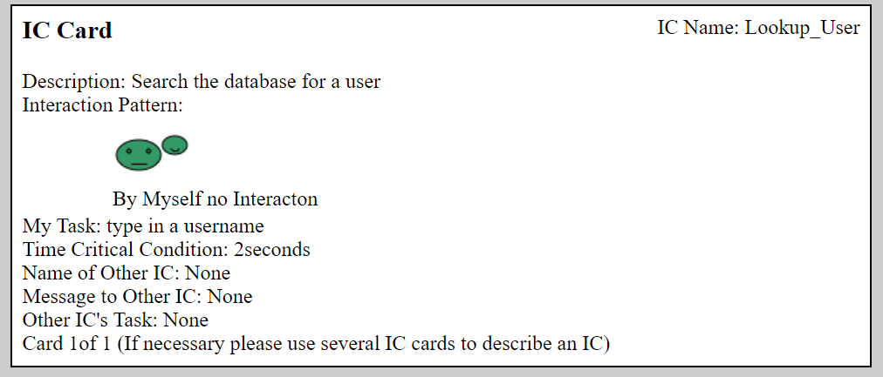

1. Delete User:

This will allow users to delete users from their contact list. If the user does not exist or is not a part of the contact list, this function will fail; warning the user that they are trying to delete an invalid contact from their list.

This feature will not search for the user to delete, it is either an exact input or failure. Also, this will only delete from the contact list of the user executing the delete function, the other user will lose the link to the one whom deleted him, but it will display the one that deleted the user as "Invalid recipient".

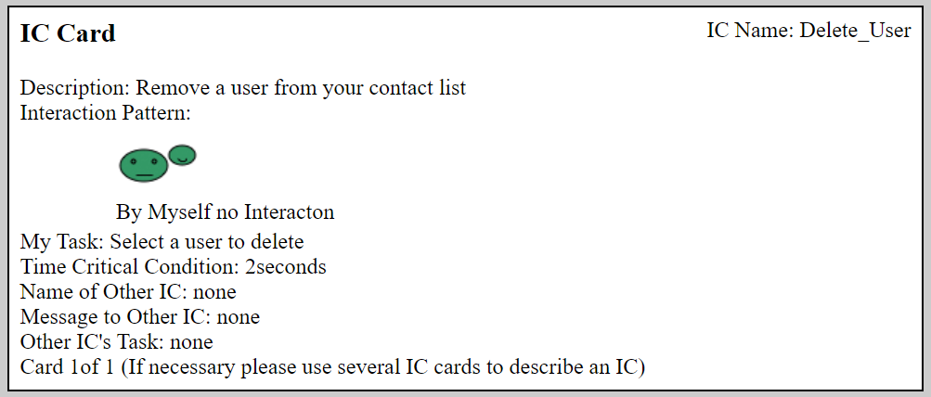

1. Accept/Deny User:

The user will have the decision to either accept or deny the “other user”, who is trying to add them as a friend. If the user accepts the request, both user can interact with one another being able to chat, see each other’s profile, call/video chat, etc. Unless if the user denies the request, the “other user” who was trying to add the user will not be able to communicate the user nor be able to see the user’s profile.

This feature can only work when the user receives a request from another user.

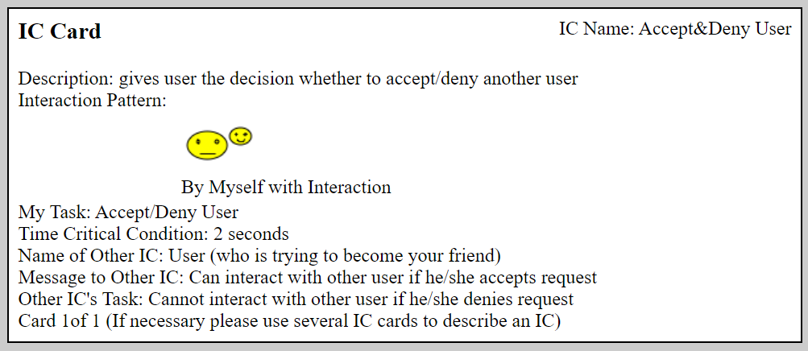

1. Block User: When a user is blocked by another user, they will no longer be able to have any communication with this user, see their profile page or search for them in the database.

To block a user, the username must be known, it cannot search for users.

1. 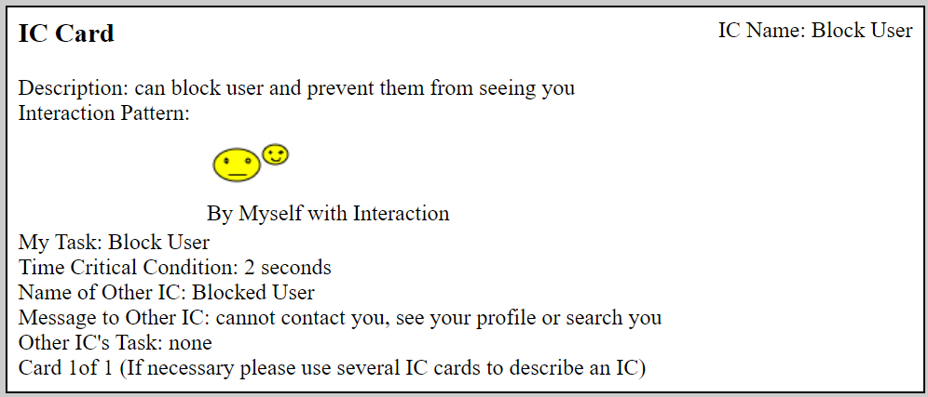Set profile: When the user registers for an account, they will be directed to their personal profile page and be able to customize it to their liking. After setting their profile, they will be able to go back and be able to change things like their profile name, profile picture, profile password, etc.

This will not allow a user to change their sign in username! That is created when they create their profile.

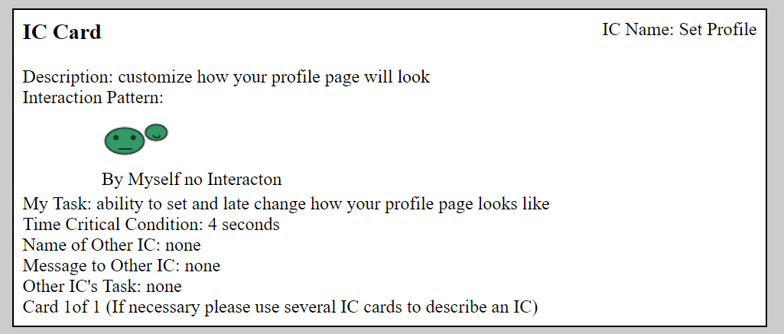

1. Post Status:

Send post, your friend can see them. It may fail when the system getting update or the servers being hack. If the function fails, maybe two things will happen, unable to post the status or can’t view posted status. If the user trying to put unsafe code or junk, it will simply display it as a string and not run it.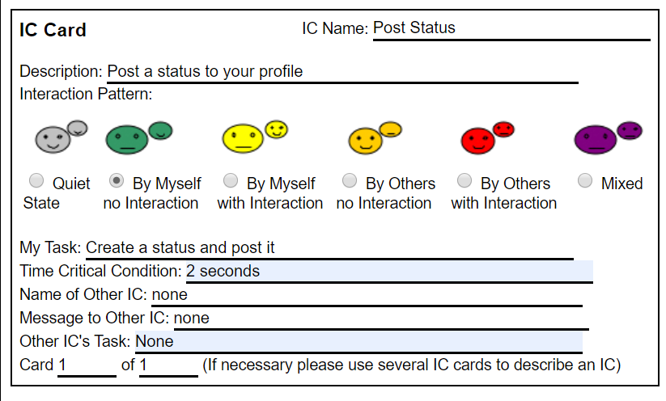

1. View Status

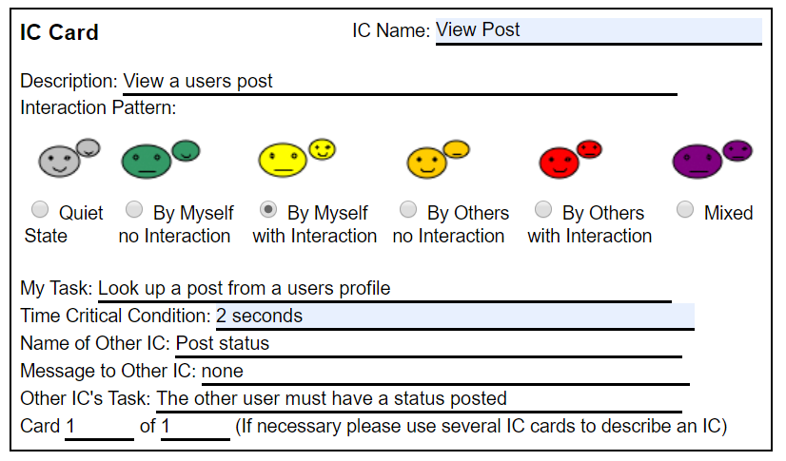Able to see friend status. It may fail when the system or database getting update. If the function fails, user cannot see other people’s post.

1. Send Messages

users can send out text message to other user, or group chat. They have no word length limitation. They can send text, numbers, or symbols.

When the user tries to send a blank message, the application should alert the user not to send empty message; when the user tries to send out more than 1000 words, the application should alert the user that they exceed the limitation of the word;

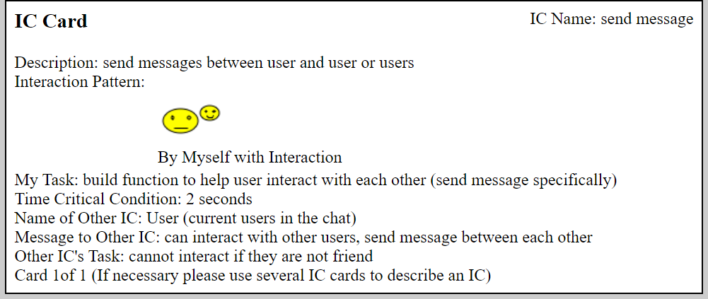If the user tries to send javascript, when output it will be treated as pure text and not run.

1. View Chat History

every time the user log out, the users’ chatting history will be stored in the database, we will store up to 7 days chat history for the user.

When the amount of data after zipping is still too big, the application will limit the amount of data. When the application uploaded the chat history successfully, the chat history will be re-open when the user uses the web application again.

